Flutter assignment

1. Registration Page:

Registration page contains field like first name, last name, phone number, email, gender, password and confirm password fields. Validations are applied on every field on this page. If all validations are done and proper, then user will be navigated to Your info page.

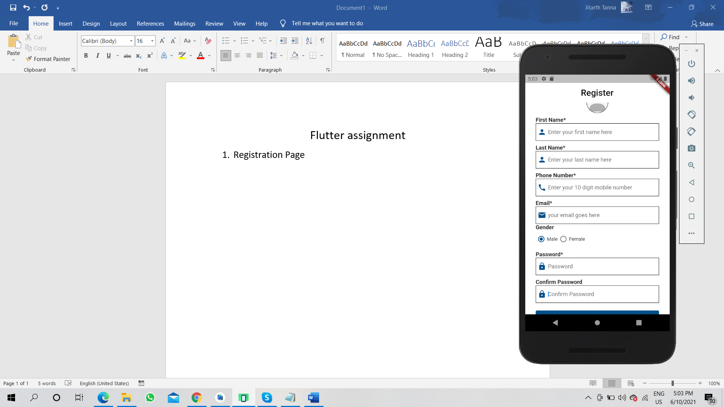

* 1. Registration Page

1. Your Info page:

Your Info page contains field about educational info like education, year of passing, and grade. Alon with it, there are professional info fields like Experience, Designation and domain. All fields are validated upon submission and if validations are proper then user will be navigated to address page.

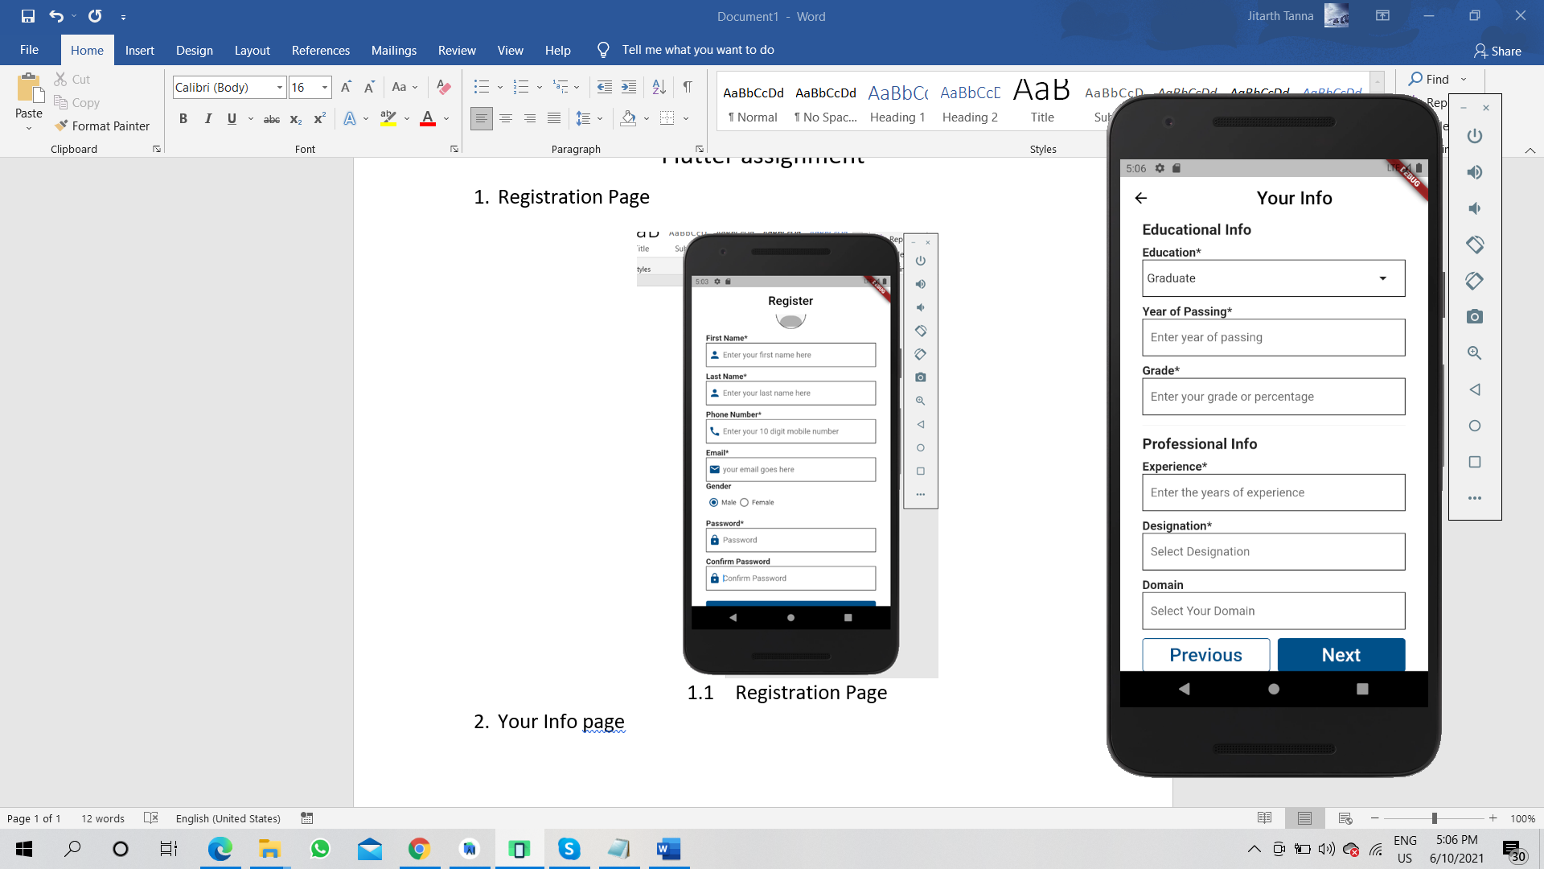

* 1. Your Info page

1. Address Page:

In this page, there are fields like address, landmark, city, state and pin code.

Validations are applied on every field. After all fields are validated, a dialog box opens with a message “User Registered Successfully”.

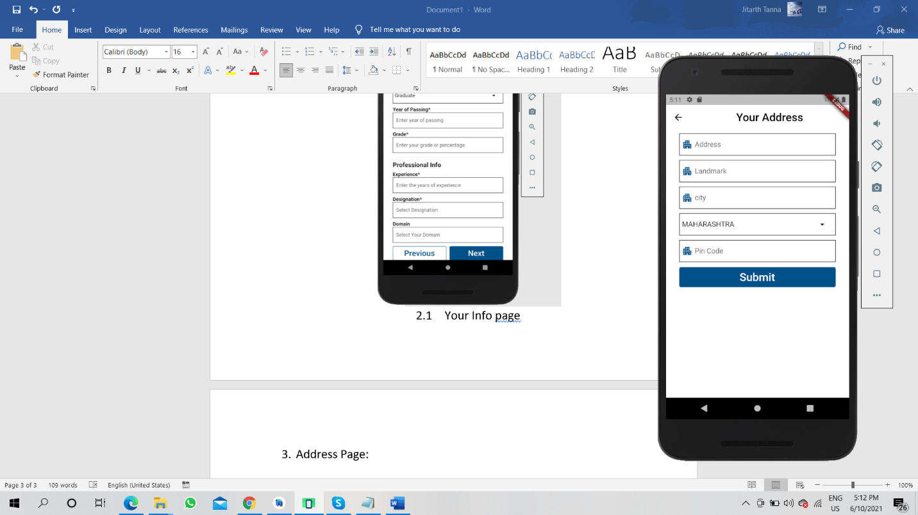

* 1. Address page

1. Some validation Screenshots:

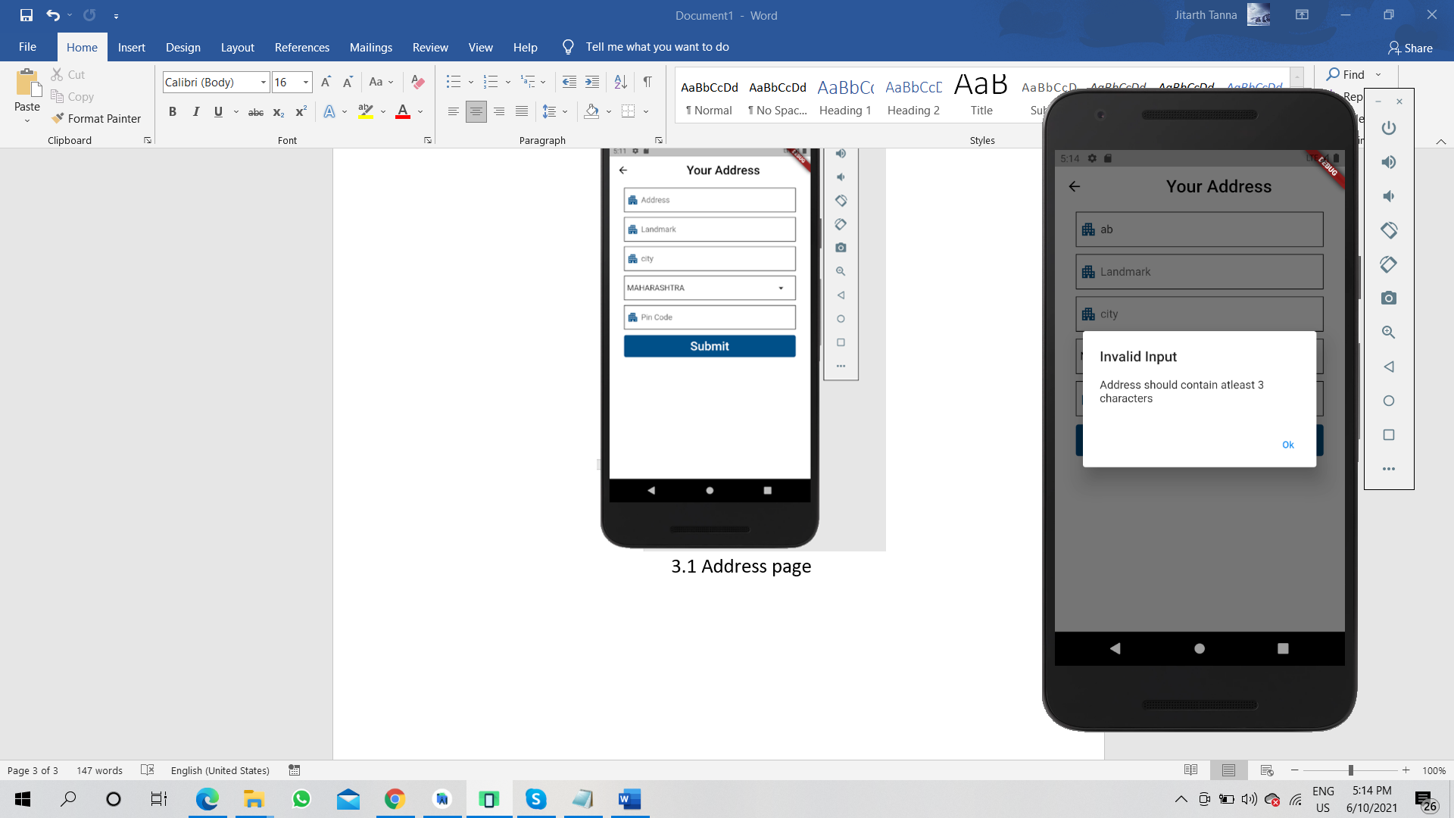 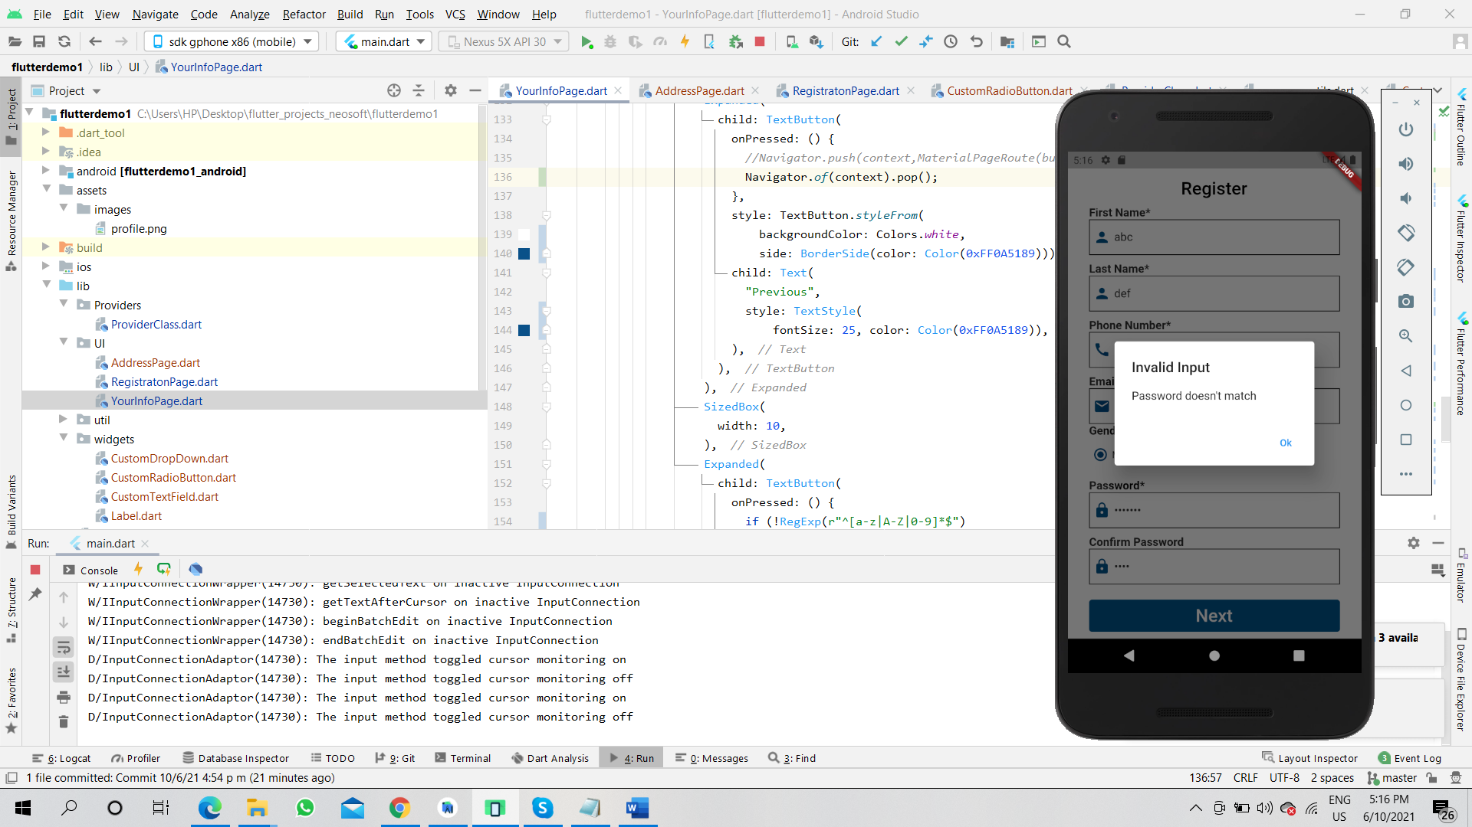

4.1 Address Validation 4.2 Confirm Password validation